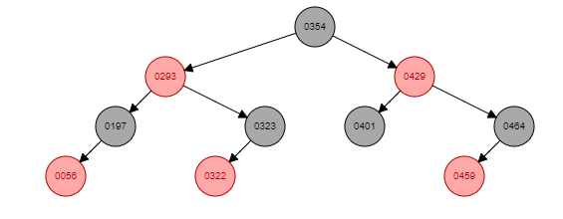

**Terminal Output:**

Parent at Insertion:

===============================

275

192

P: 275

13

P: 192

122

P: 192

257

P: 275

422

P: 275

310

P: 422

254

P: 257

116

P: 192

15

P: 116

===============================

Traversal

===============================

1315116122192254257275310422

===============================

Removing fourth element

===============================

1315116192254257275310422

During my testing, there were a few times where parent nodes wouldn’t be printed alongside the traversal, and couldn’t figure out why. Since I used the support code given, it had to have been something with the print function. The project was difficult to decode and understand everything that was given to us, understanding what was written to us was difficult, but overall extremely useful because we will need to be able to read other’s codes in the job field.